
Linux Commands

- ls

What: Lists files and directories in the current folder.
Why: To see the contents of the directory you are working in.

Lists files and directories in the current directory.

- pwd

What: Prints the current working directory (full path).
Why: To know exactly where you are in the filesystem.

Shows the present working directory (current location).

- dir

What: Lists files and directories (similar to ls).
Why: Alternative way to view directory contents, sometimes useful in scripts.

Also lists files and directories (alternative to ls).

- touch

What: Creates an empty file or updates an existing file’s timestamp.
Why: Quickly create files to start editing or track changes.

Creates an empty file or updates file timestamp.

- nano

What: Opens a text file in the Nano editor.
Why: To create or edit text files directly in the terminal.

Opens a file in the nano text editor.

- cat

What: Displays file contents in the terminal.
Why: To read files quickly without opening a text editor.

Displays file content on the terminal.
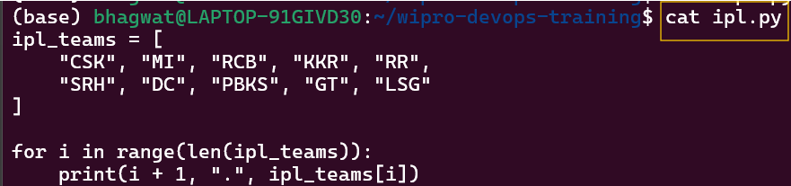

- cd . .

What: Moves one directory up (to the parent directory).
Why: To navigate backwards in the filesystem hierarchy.

Moves one directory back (parent directory).

- mkdir

What: Creates a new directory.
Why: To organize files into folders.
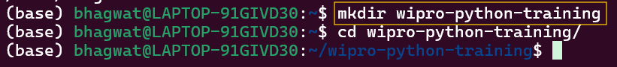
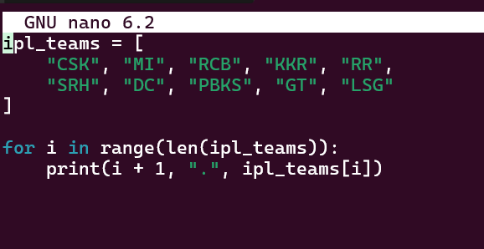
Creates a new directory.

- whoami

What: Shows the currently logged-in user.
Why: To check which user account is active, important for permissions.

Displays the current logged-in user.

- mv

What: Moves or renames files and directories.
Why: To relocate files or give them a new name.

Moves or renames files/directories.

- rmdir

What: Deletes an empty directory.
Why: To remove unused folders safely without affecting files.

Deletes an empty directory.

- rm -rf

What: Deletes files or directories recursively and forcefully.
Why: To remove directories and their contents permanently

Deletes files or directories forcefully and recursively.

- cd ../..

What: Moves two directories up from the current directory.
Why: Quick way to navigate higher in the folder hierarchy.

Moves two directories back (up) from the current directory.

- cp

What: Copies files or directories from one location to another.
Why: To create backups or duplicate files without affecting the original.

Copies files or directories from one location to another.
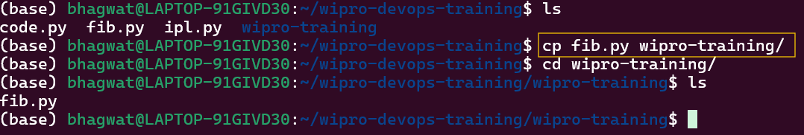

- mv ..

What: Moves the parent directory or files to a new location (used with target path).
Why: To relocate directories or files up one level safely.

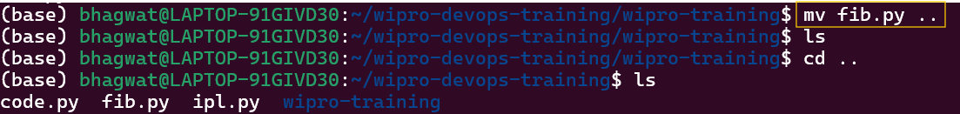

- wget <URL>

What: Downloads a file from the internet.
Why: To fetch files directly into your Linux system without using a browser.

Downloads a file from the internet.
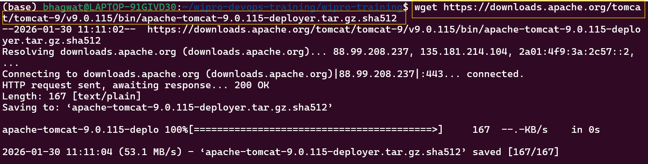

- ping

What: Sends network packets to a server to check connectivity.
Why: To verify if a website or server is reachable and measure response time.

Checks network connectivity
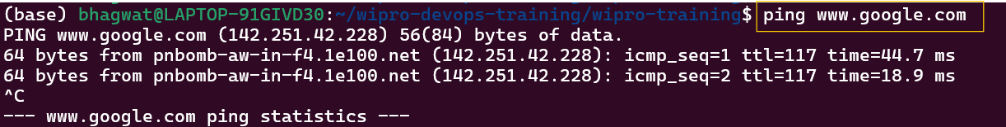

- History

What: Displays all previously executed commands.
Why: To review, repeat, or delete commands from your terminal session.

Displays all previously executed commands.
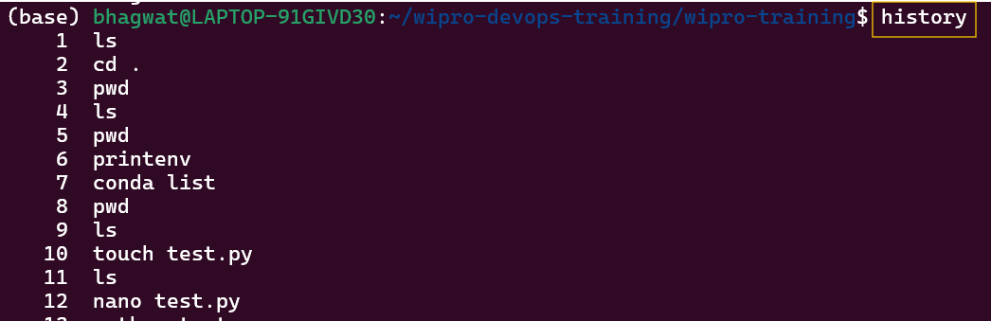

- df

What: Shows disk space usage of mounted filesystems.
Why: To monitor free space and prevent storage issues.

Displays disk space usage of all mounted filesystems.
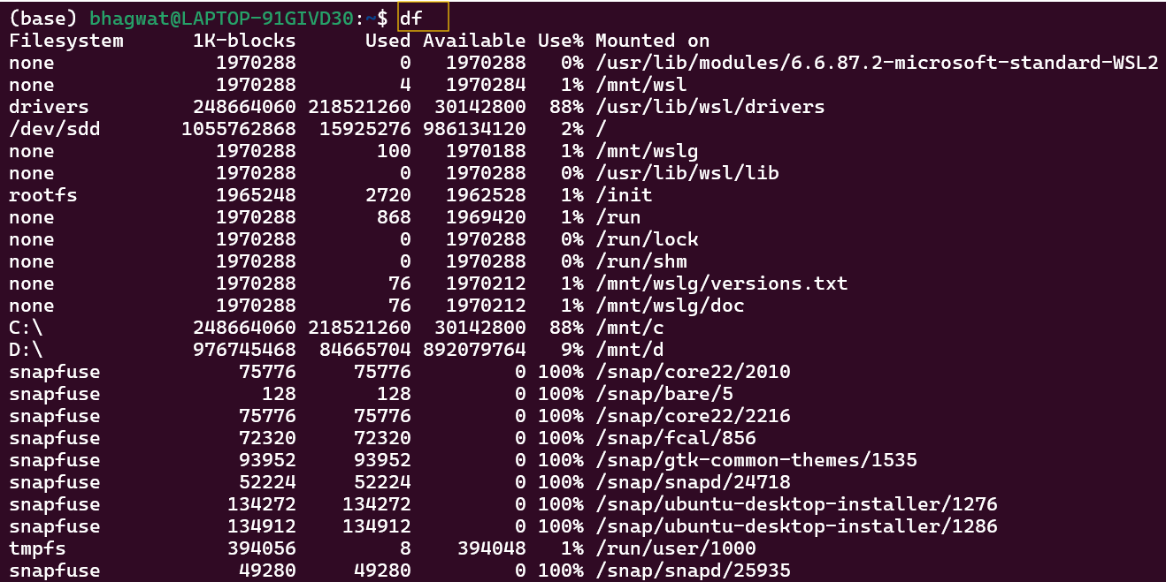

- fcal

What: Displays a calendar of the current month or a specified month/year.
Why: To quickly check dates from the terminal.

Displays a calendar.
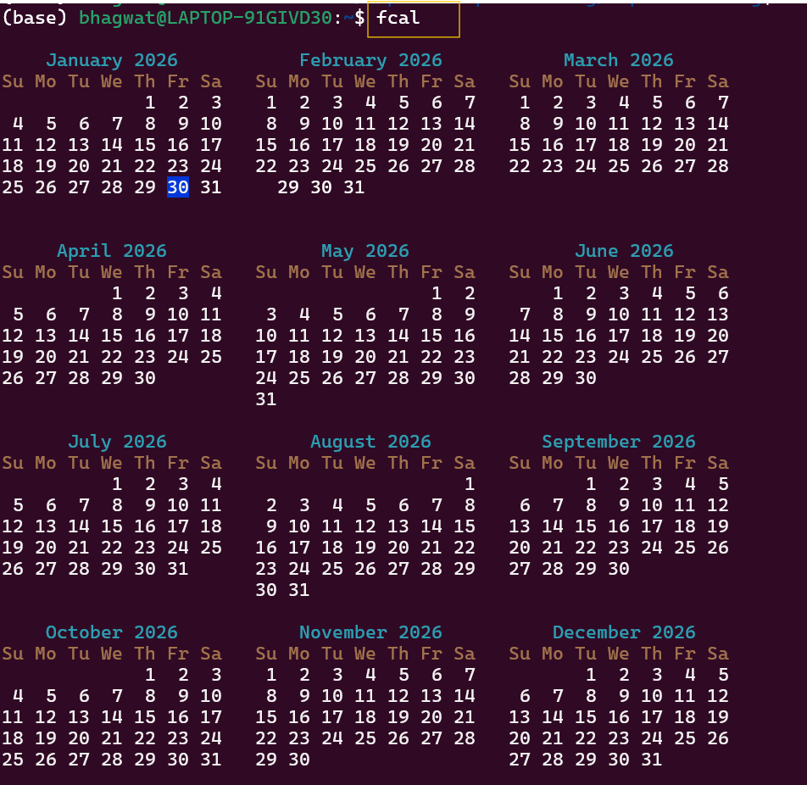

- chmod u+x ipl.py

WHAT:
Adds execute (x) permission to the user (owner) of ipl.py.

WHY:
So the owner can run the Python file as a script

Adds execute permission to the user (owner).
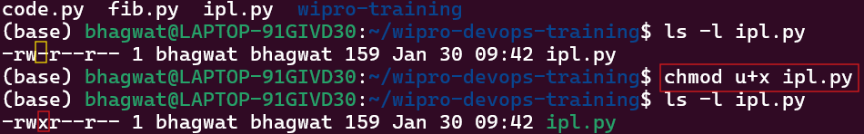

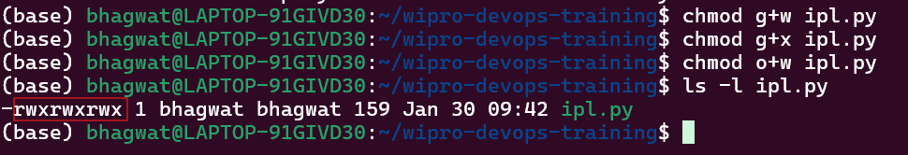

- chmod u-x ipl.py

WHAT:
Removes execute (x) permission from the user (owner).

WHY:
To stop the owner from executing the file while keeping other permissions unchanged.

Revokes execute permission to the user (owner).
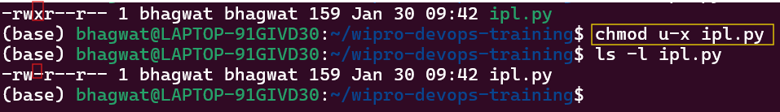

- chomd 000 ipl.py

WHAT:
Removes all permissions (read, write, execute) from User, group and others

WHY:
To completely block access to the file for everyone.

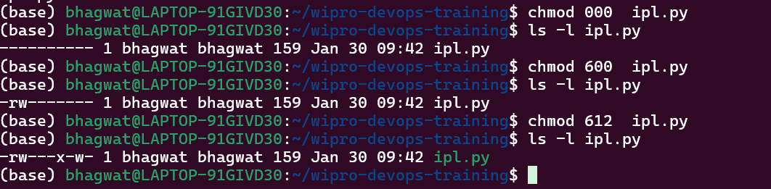

- chmod 600 ipl.py

WHAT:
Sets permissions as:
- User (owner): read + write (rw-)
- Group: no permissions (---)
- Others: no permissions (---)

WHY:
To make the file private:
- Only the owner can read and edit
- No one can execute it
- Group and others have no access

- chmod 612 ipl.py

WHAT:
Sets permissions as:
- User: read + write (rw-) → 6
- Group: execute only (--x) → 1
- Others: write only (-w-) → 2

WHY:
This is mainly for learning numeric permissions:
- Owner can read and edit
- Group can only execute
- Others can only write (unusual & unsafe in real systems)

- Sudo add bhagwat

WHAT:
Creates a user named(basic account only).
WHY:
To add a user.

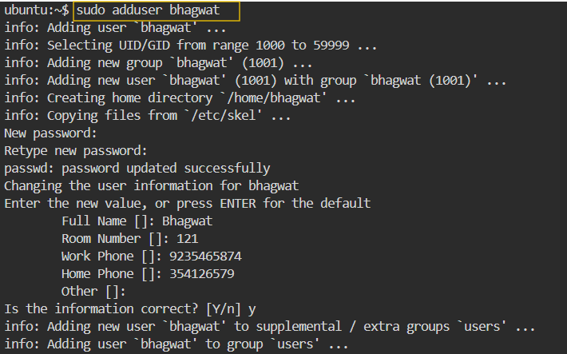

- su – bhagwat

WHAT:
Switches to user bhagwat with login environment.
WHY:
To fully act as user bhagwat (home, path, env).

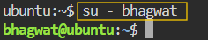

- cat /etc/passwd

WHAT:
Displays all user account entries.
WHY:
To view all users in the system.
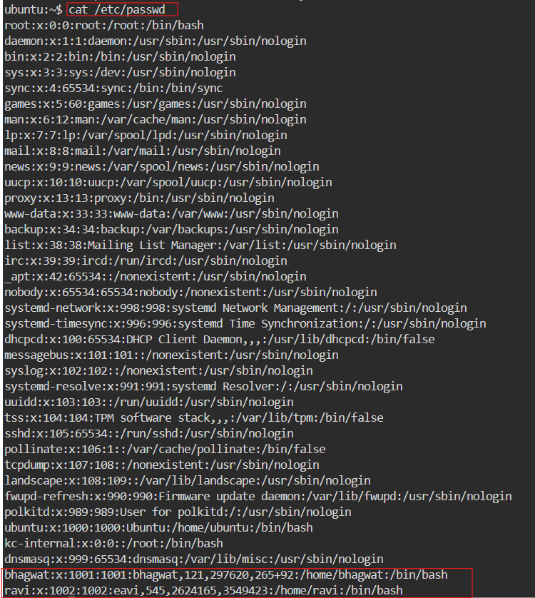

- cut -d: -f1 /etc/passwd

WHAT:
Shows only usernames from /etc/passwd.
WHY:
To get a clean list of users.

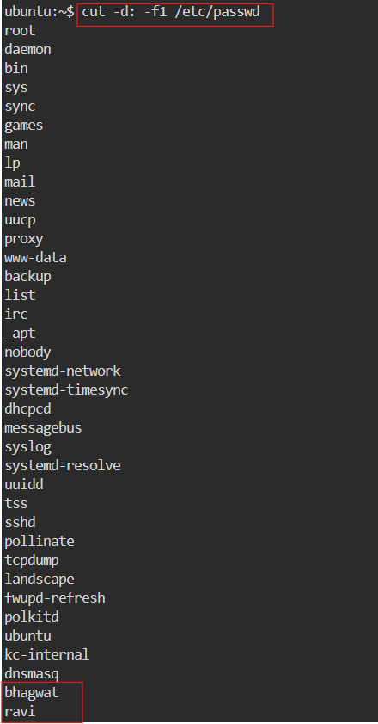

- id bhagwat

WHAT:
Displays UID, GID, and groups of user bhagwat.
WHY:
To check user and group details.

- sudo userdel ravi

WHAT:
Deletes user bhagwat (home dir not removed).
WHY:
To remove the user account.

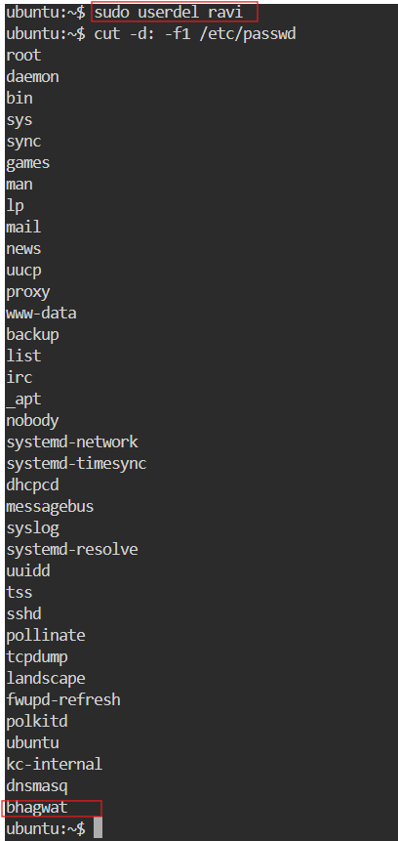

- System Commands

- uname : used to get type of OS
- uname -r : used to get kernel version of our OS
- uname -a : used to get full info about OS
- clear: this command is used to clear the clear (or) you can use ctrl + l as a short cut
- uptime : used to get since how long our system is in running state
- uptime -p : this will give only time
- hostname: used to get private dns name of our system
- hostname -i : used to get private ip of our system
- hostnamectl set-hostname “swiggy” : used to change hostname
- ip addr : used to get private IP
- ip route : used to get private IP
- ifconfig : used to get private IP
- date : to get todays date
- timedatectl : used to get timezones
- timedatectl set-timezone Asia/Kolkata : used to change Timezone to IST
- who : used to see how many users have been loggin into your system
- whoami : used to see the current user.
- ps : used to see the running processors in system
- kill -9 PID : used to kill a processor
- date : Shows system date and timestamp
- date +”%d” : Prints day of the month (01-31)
- date +”%m” : Prints the month of the year 01-12
- date +”%y” : Prints only the last two digits of Year
- date +”%H” : Prints the hour 00-23
- date +”%M” : Prints the Minute of the hour 00-59
- date +”%S” : Prints the current seconds count in the minute (00-60)
- date +"%D" : Prints Date in MM/DD/YY
- date +”%F” : Prints only the Full date as YYYY-MM-DD
- date +”%A” : Prints the Day of the Week Saturday-Sunday
- date +”%B” : Prints the month between January-December

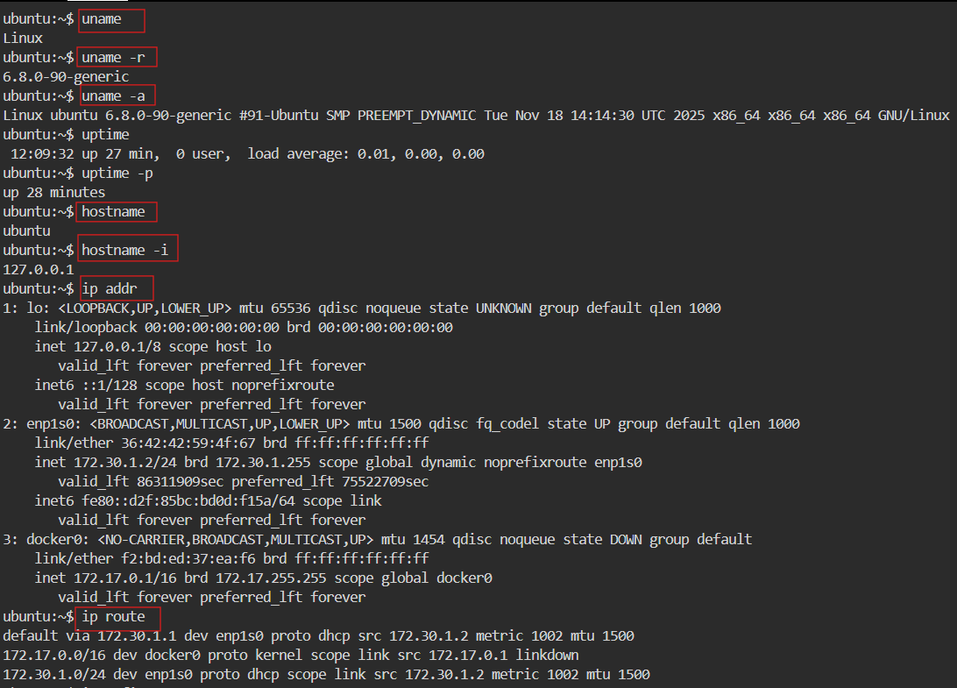

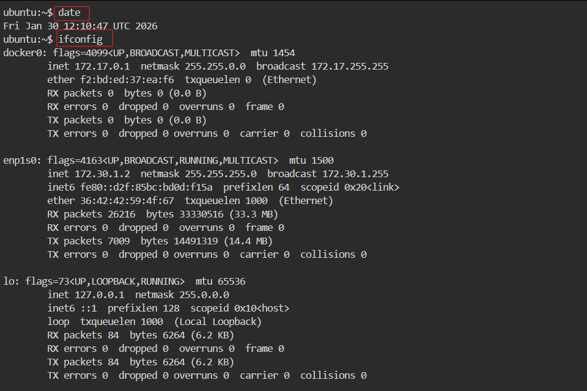

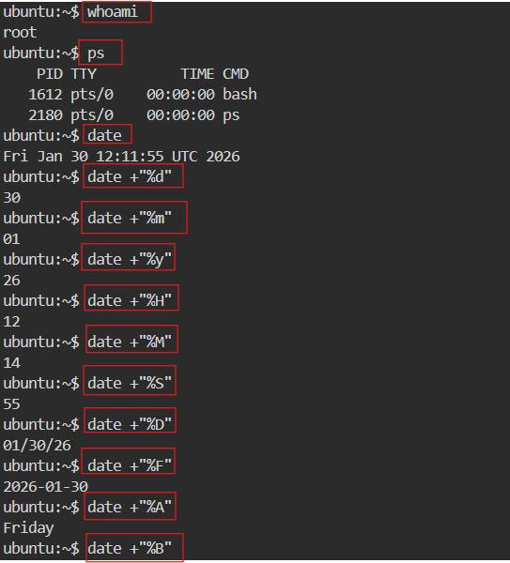

- Hardware Commands

- lscpu (or) cat /proc/cpuinfo : Displays information about the CPU architecture
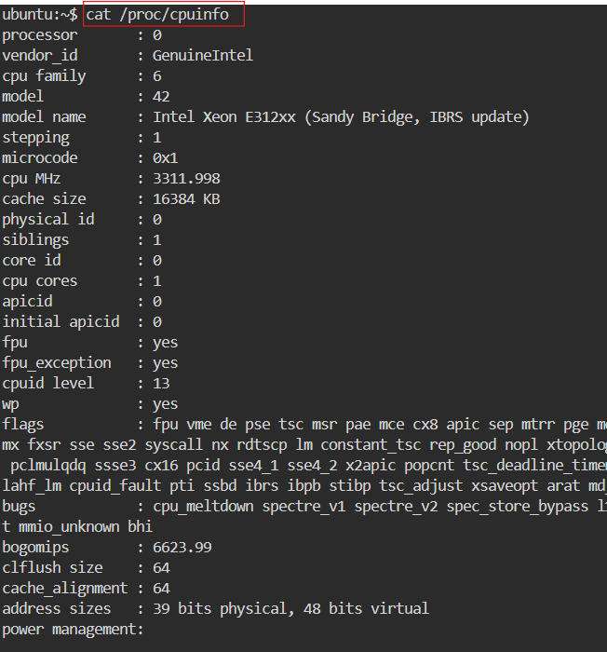
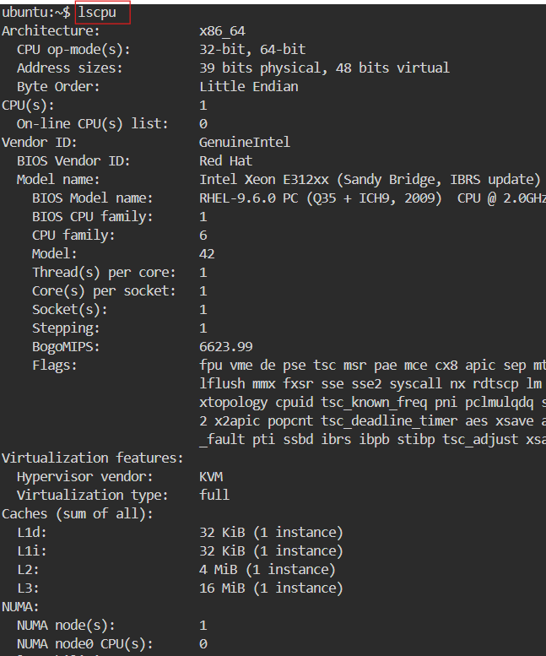

- lsblk -a : Lists the information about all the block devices attached to the system

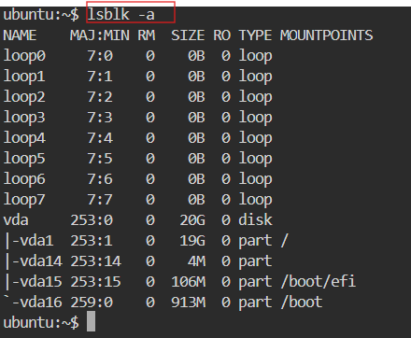

- free (or) cat /proc/meminfo: Displays system memory(RAM) details in KB

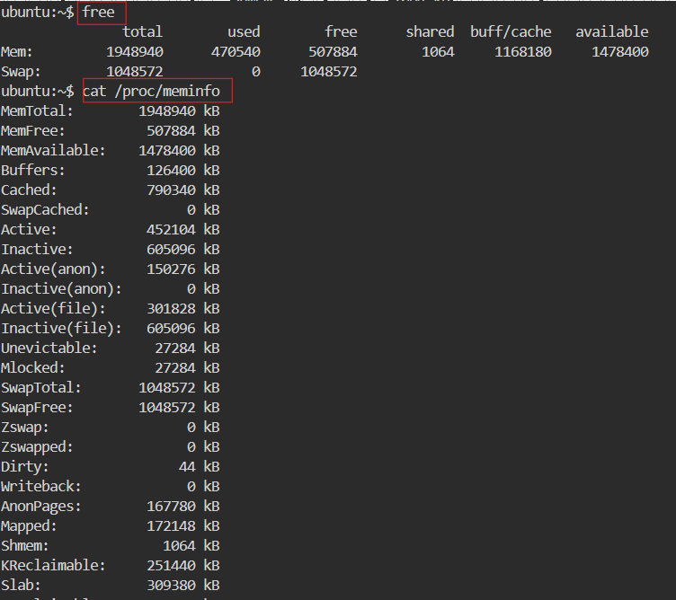

- free -m : Displays system memory(RAM) details in MB
- df -h : Report file system disk space usage in human readable languages

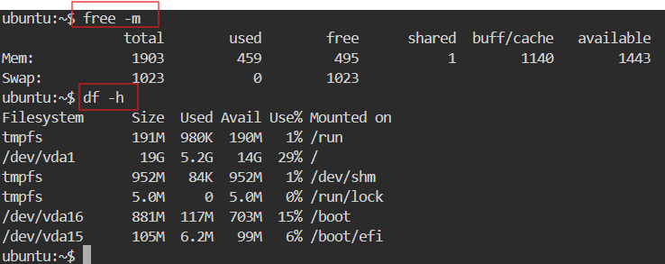

- GREP (Global Regular Expression Print)

SYNTAX: grep “word” filename
- grep “word” filename : used to search for a word in a file
- grep -n “word” filename : it prints the data along with line numbers
- grep -c “word” filename : it prints no of occurances of a word
- grep -i “word” filename : used to search for a case-sensitive

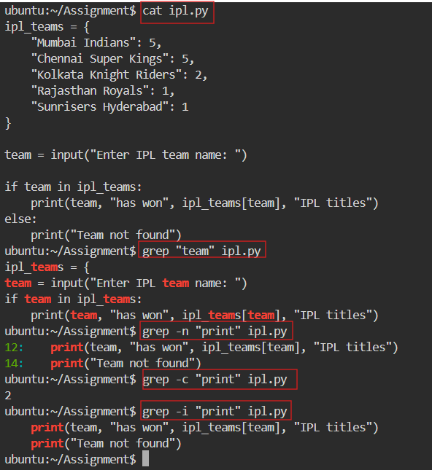

- cd

